## **Supplement: Updating Notepad++ to Handle Markdown**

**Notepad++** is the most common plain text editor for Windows computers. These instructions for adding Markdown support to the standard Notepad++ installation come from this site:

<https://adamtheautomator.com/convert-markdown-to-html/>

**Markdown in Notepad++**

[*Notepad++*](https://notepad-plus-plus.org/downloads/) is a popular, free editor with several plugins available that you can install to extend its capabilities. One of these plugins is the *MarkdownViewer++,* which adds the feature to render and export Markdown contents to HTML.

You can install the *MarkdownViewer++* plugin by going to **Plugins —> Plugins Admin**. Once inside the **Plugins Admin** window, select the **MarkdownViewer++** and click on **Install**. When prompted, click **Yes**. Notepad++ will restart automatically.

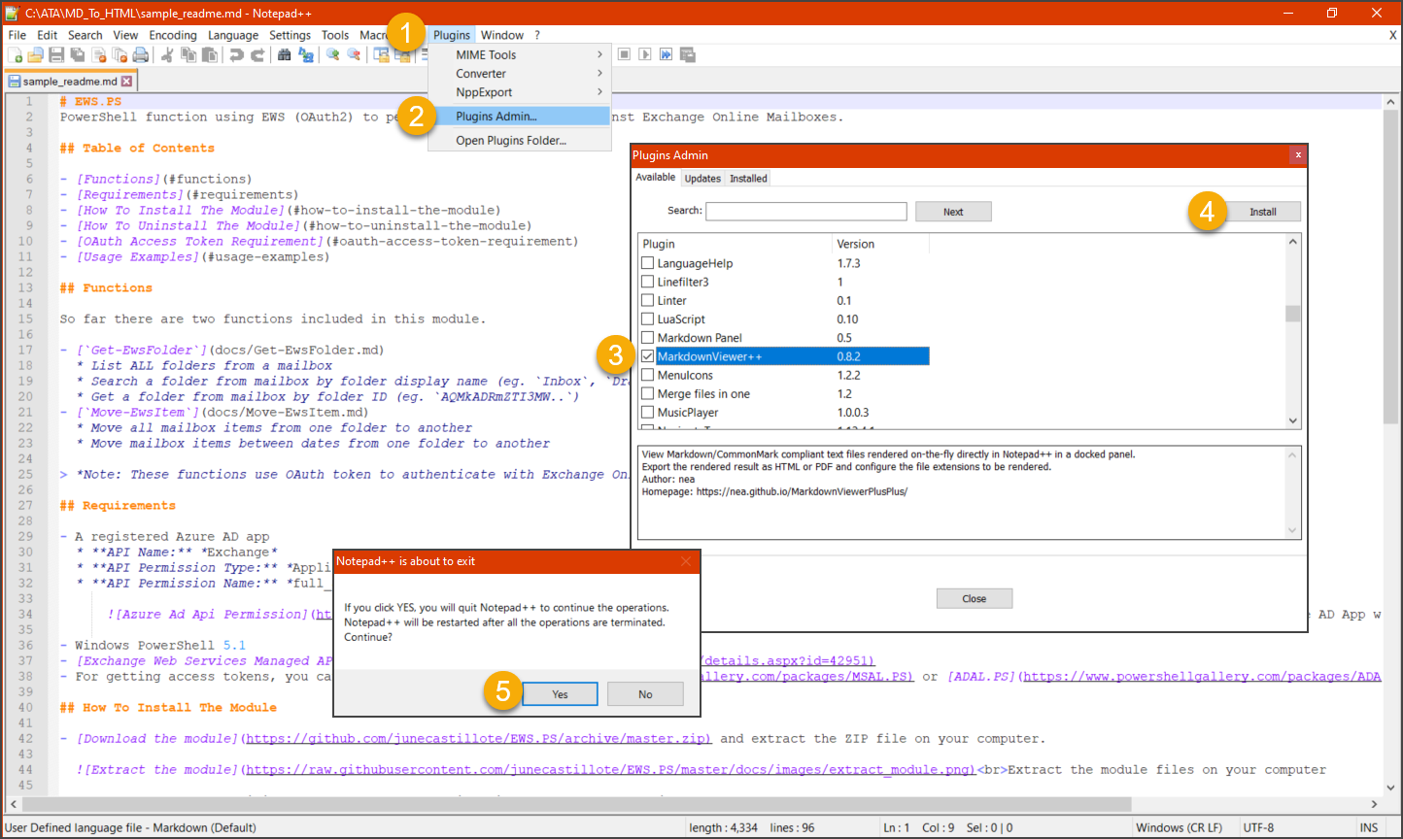

*Installing the MarkdownViewer++ plugin*

After the plugin is installed, open the Markdown file and click on the **MarkdownViewer++** button. The pane where the HTML rendering of the Markdown file should show up. To export the content, click on **Export as —> HTML**. Then, save the file in your chosen location.

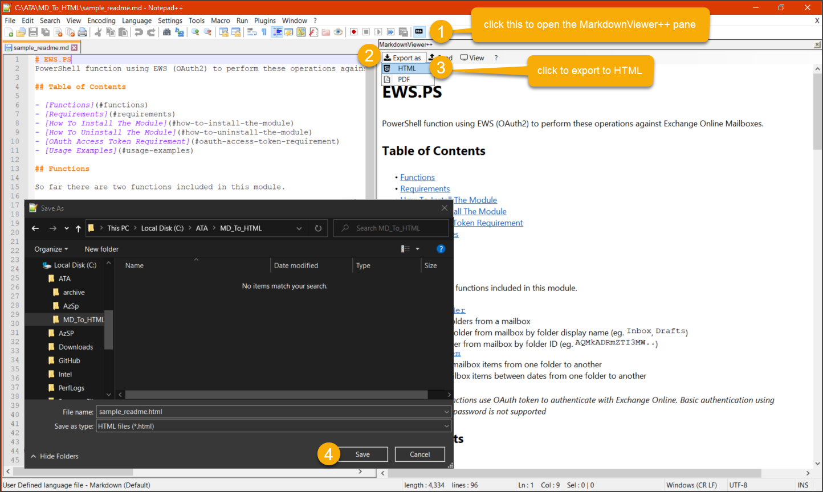

*Convert Markdown to HTML using Notepad++*

Below you can see that the HTML output is plain and has no style formatting.

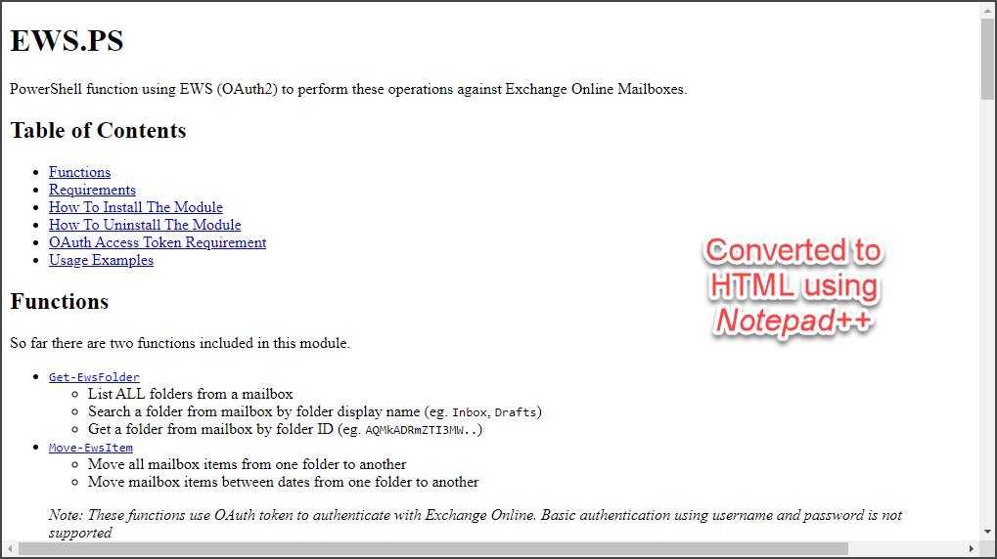

*HTML output format using Notepad++*